Predicting Biological Age Based on Vascular and Cognitive Assessments in Preclinical Mouse Model Using a Block-Wise Missing Data Framework

Background and Purpose: Aging is one of the leading risk factors for neurological disorders, including vascular cognitive impairment and dementia. Predicting biological age, a parameter that can differentiate healthy and pathological aging, requires the integration of cellular and physiological measurements. Using fast life-cycle animal models such as mice provides an opportunity to assess biological age in both healthy and pathological conditions in parallel to chronological age. Unlike in human studies, some cellular and physiological neurovascular measurement requires terminal anesthesia of the animal which introduces significant data scarcity. The objective of this study is to introduce and evaluate a computational framework designed to predict biological age relative to chronological age using vascular and cognitive readouts in datasets with structured patterns of variable-level missingness.
Methods: 214 p16^{INK4A} trimodal reporter (p16-3MR) transgenic mice across 23 variables have been analyzed. Based on their chronological age, the animals have been sorted into 5 age groups from very young to very aged. Due to the nature of data collection in preclinical studies, the dataset exhibited high missingness: only 24 samples had complete data, with a median of 14 missing variables per sample. Data availability ranged from 83.6% for BBB permeability (40 kDa dextran) down to 22.4% for endothelial cell flow cytometry. We utilized a block-wise missing data model to retain all 214 records, integrating neurovascular measurements (BBB permeability, capillary density, neurovascular coupling) and endothelial senescence burden and cognitive parameters without relying on case-wise deletion or imputation.
Results: The framework was tested in two experiments. Experiment 1 merged very young and young cohorts to address class imbalance, achieving an average accuracy of 80.7% and 87.8% macro-specificity. Experiment 2 excluded these younger samples to isolate the biological inflection point from middle-aged to very aged mice (15–32 months), maintaining a 70.6% average accuracy and 80.7% macro-specificity.
Conclusion: This block-wise missing data framework effectively predicts biological age and by measuring cellular and physiological vascular parameters. By retaining highly sparse records, it offers a robust alternative to conventional imputation strategies for modeling complex neurovascular and senescence-related phenotypes.

Keywords:
Block-wise missing data, cellular senescence, biological age, neurovascular coupling, multi-omics integration.

1. Introduction
The global population is aging rapidly as life expectancy continues to improve. However, this demographic shift is accompanied by an increased prevalence of dementia (Baker et al., 2018; Onyango et al., 2021; Rashid et al., 2024; Robbins et al., 2021; Van Skike & Galvan, 2020), which is projected to affect about 106 million individuals worldwide by 2050 (Brainin et al., 2020); more recent estimates suggest that this number could exceed 137 million (Cai et al., 2026). Among these cases, vascular cognitive impairment (VCI) accounts for a significant proportion, estimated between 20–40% (Linh et al., 2022), a burden that is expected to grow as population aging accelerates." Neurovascular dementia remains the second leading cause of dementia and is primarily driven by vascular cognitive impairment (VCI), particularly in its advanced stages. Emerging evidence indicates that individuals with VCI experience significantly higher dependence, which can contribute to substantial socioeconomic burdens (Csik et al., 2025; T O’Brien et al., 2003; A. Ungvari et al., 2025). VCI accounts for a significant portion of all dementia cases, estimated between 20–40% (Linh et al., 2022), and this burden is expected to grow as population aging accelerates.
Aging-related microvascular alterations in the brain are considered a key underlying biological mechanism for developing VCI (Sweeney, Kisler, et al., 2018; Sweeney, Sagare, et al., 2018). These changes can impair neurovascular coupling (NVC), a biological process that adjusts the cerebral blood flow based on the metabolic demands of active brain regions (Toth et al., 2017). Such alterations can further disrupt the blood-brain barrier (BBB), which provides a permeability barrier against inflammation-inducing or other toxic substances. Moreover, age-associated microvascular rarefactions in brain further intensify these impairments as the progressive loss of blood micro vessels can further limit the brain’s ability to respond to metabolic demands (van Dinther et al., 2022). These interconnected mechanisms collectively contribute to cerebromicrovascular dysfunction and ultimately to the progression of VCI (Van Skike & Galvan, 2020).
One manifestation of age-related microvascular alterations in the brain is the accumulation of senescent endothelial cells and their senescence-associated secretory phenotype (SASP), which has been shown to contribute to cognitive impairment (Kiss et al., 2020; Z. Ungvari et al., 2013). Preclinical studies further indicate a significant role for senescent cells and their SASPs in the development of cerebromicrovascular pathologies. Accordingly, emerging research has demonstrated promising improvements in cognitive function and lifespan in mouse models following the selective depletion of senescent cells, particularly those expressing the p16^{INK4A} biomarker (Faakye et al., 2024; Kim et al., 2019). In our recent works, we have discussed the promising results of senolytic treatments on enhancing the endothelial regulation of cerebral blood flow and alleviating hypertension-induced cerebral microhemorrhages in aged mice (Faakye et al., 2024; Tarantini et al., 2021).
In preclinical models, several senolytic approaches have demonstrated efficacy. Among these, our research focuses on two key strategies. The first involves genetic ablation through ganciclovir (GCV) administration in p16-3MR transgenic mice, which enables targeted elimination of p16^{Ink4a}-positive senescent cells by activating the herpes simplex virus thymidine kinase encoded in the transgene (Demaria et al., 2014; Yabluchanskiy et al., 2020). The second approach involves pharmacological intervention using ABT-263/Navitoclax, a senolytic agent that inhibits B-cell lymphoma (BCL) 2/BCL-xL and induces apoptosis in senescent cells (Chang et al., 2016). Studies utilizing genetically modified mice with depletion of cells expressing the senescence marker p16^{Ink4a} have shown significant improvements in lifespan, healthspan, microvascular function, and cognition (Baker et al., 2011, 2016; Farr et al., 2017; Roos et al., 2016). Treatment with ABT-263/Navitoclax has been shown to improve NVC responses, restore BBB integrity, increase capillary density, and enhance cognitive performance in aged mice (Csik et al., 2025; Tarantini et al., 2021). Furthermore, elimination of senescent cells by ABT-263 treatment restored BBB function in models of accelerated senescence induced by whole-brain irradiation (Ahire et al., 2023). Despite these promising results, the impact of senolytic interventions on biological age and its correlation to functional organ decline remains unclear, and more research is needed to better understand the causes of aging and its effects.
Data-driven approaches have been used extensively to predict cerebrovascular diseases leading to cognitive impairment using various datasets, ranging from clinical data to imaging features (e.g., MRI-derived measures). For example, Borchert et al. (2023) identify 255 studies of artificial intelligence studies relevant to Alzheimer and dementia, including vascular dementia. Most recently, Wu et al. (2025) provide an extensive meta-analysis of machine learning (ML) algorithms for cognitive impairment due to cerebrovascular diseases. ML-based approaches have also been employed to predict the biological age in both healthy cohorts and patients having cerebrovascular disease. For example, Cumplido-Mayoral et al. (2023) used an XGBoost model to predict brain age from MRI scans of 22,661 cognitively healthy individuals in the UK Biobank. This model achieved a mean absolute error of 4.19 years (Pearson R = 0.71) for brain-age prediction. In another study, Fernández-Pérez et al. (2023) used Hannum's epigenetic clock to measure biological age based on DNA methylation in blood samples from 952 patients with cerebrovascular disease. However, to the best of our knowledge, no study has examined the prediction of changes in biological age following senolytic treatment in the context of VCI. To assess the existing literature, we conducted a PubMed search using the query “((senolytic) AND (biological age)) AND (machine learning).” Among the identified publications (n = 12), none applied machine learning–based predictive models to estimate biological age, either in human or murine models, as an outcome of senolytic interventions.
This study is the first to systematically integrate multidimensional clinical phenotyping in p16-3MR transgenic mouse models by incorporating quantitative assessments of BBB permeability across molecules of distinct molecular weights, together with evaluation of therapeutic interventions, to model and predict divergence between biological and chronological age.
2. Materials and Methods
2.1. Dataset
The data used in this study were obtained from the University of Oklahoma Health Campus and generated in p16-3-Modality Reporter transgenic mice. In this model, p16-driven reporter expression enables targeted clearance of p16 positive senescent cells and facilitates evaluation of senolytic interventions in age-related neurovascular dysfunction. The compiled dataset included mouse-level study descriptors such as chronological age group, vascular biological age label, and treatment assignment, together with vascular, neurovascular, synaptic, and cognitive outcomes. The primary vascular outcome measure was BBB permeability, quantified using fluorescent tracer-based leakage assays across multiple molecular sizes, including 40 kDa and 3 kDa dextran and 0.3 kDa sodium fluorescein, which capture size-dependent barrier disruption. BBB permeability was computed from fluorescence-based leakage curves using an area under the curve summary, reported in arbitrary units. Additional outcome domains included microvascular morphology and neurovascular coupling, measured using established in vivo imaging techniques, together with synaptic plasticity and cognitive performance measures.
To assess how senescent cell burden modulated vascular aging trajectories, animals were evaluated under three treatment conditions: no treatment, genetic senescent cell clearance via GCV, and pharmacological senolysis using ABT-263. These interventions enabled controlled comparisons between natural age-related vascular decline and senolysis-associated remodeling of neurovascular phenotypes. The treatment definitions used in the dataset are summarized in Table 1.

Table 1. Summary of experimental treatment protocols
Treatment Group | Sample Size | Age Range (Months) | Primary Intervention
No Treatment (NT) | 127 | 4 – 32 | Natural Aging Control
Ganciclovir (GCV) | 39 | 15 – 32 | Genetic Senescent Cell Clearance
Navitoclax (ABT-263) | 48 | 15 – 32 | Pharmacological Senolysis

The dataset contained $n$ = 214 mouse records, spanning five chronological age strata to capture the full spectrum of vascular aging: Very Young (4–6 months), Young (10–14 months), Middle-Aged (15–17 months), Aged (18–20 months), and Very Aged (21–32 months). This sampling was designed to capture a broad portion of the murine lifespan and support learning of nonlinear age-related vascular changes. The distribution of mice across age strata and treatment assignments is summarized in Figure 1.

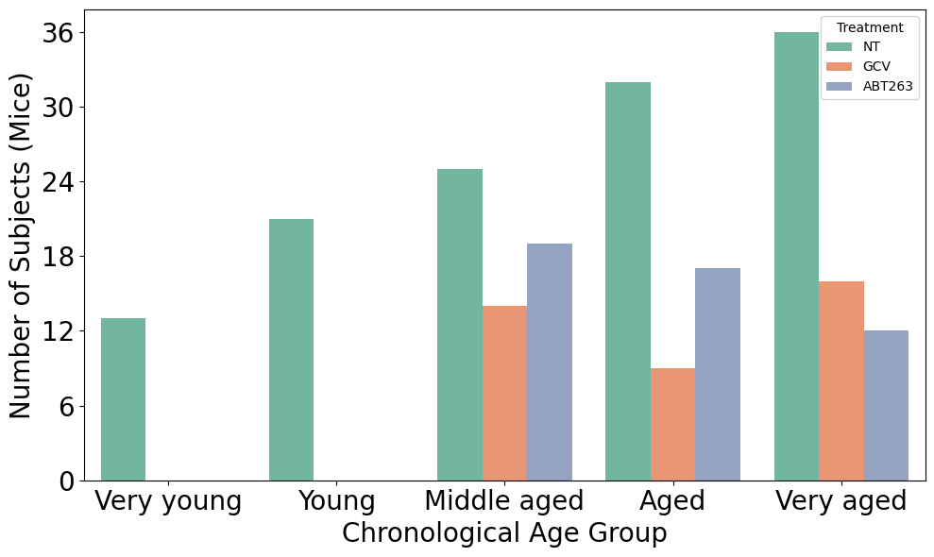

Figure 1. Distribution of samples across age groups and treatment conditions

The main features considered in this study are listed in Table 2. The primary focus was the assessment of BBB integrity, measured using intravital two-photon microscopy to assess the extravasation of fluorescent dextran tracers. Tracers of varying molecular weights, 40 kDa, 3 kDa, and 0.3 kDa (sodium fluorescein), were sequentially injected to quantify paracellular permeability across the cerebral microvasculature. These molecular metrics were integrated with other functional domains, including neurovascular function (assessment of NVC responses to monitor the synchronization between neuronal activity and regional cerebral blood flow), vascular morphometry (quantification of capillary density and length density to identify microvascular rarefaction), cellular senescence load (flow cytometry-based counts of senescent endothelial cells, microglia, and astrocytes), and cognitive assessment (Spatial learning and memory performance indices derived from the Radial Arm Water Maze [RAWM]).

Table 2. Summary of Feature Categories
Category | Feature  Type | # Features | Description | Treatment  Group
BBB Permeability | Numerical | 3 | Three BBB permeability values using specific fluorescent dextran tracer sizes (40 kDa, 3 kDa, 0.3 kDa) | No Treatment, GCV, ABT
Neurovascular & Vascular | Numerical | 3 | Neurovascular coupling, vascular length density and vascular area coverage | GCV, ABT
Flow cytometry | Numerical | 1 | endothelial cells (CD31⁺), microglia (CD11b⁺), astrocytes (GLAST⁺), pericytes (CD140b⁺) | GCV, ABT
Long‑term potentiation | Numerical | 1 | Gray matter volume, cortical thickness, brain age gap | GCV, ABT
Radial Arm Water Maze | Numerical | 12 | Early and late-phase performance values, improvement score, learning index, total errors, area under curve, learning slope, performance score, right- and left-arm errors, retention scores, and first-choice cost | No Treatment, GCV, ABT

2.2. Block-wise Missing Data Framework
The main characteristic of this dataset was the presence of structured block-wise missingness driven by experimental design constraints and assay logistics. Specifically, several outcomes were collected as assay-level panels that were either fully obtained or not obtained for a given animal, which produced contiguous missingness across related variables rather than isolated missing entries. The dataset includes 23 variables. On average, each observation sample contained a median of 14 missing variable, and only 24 of the 214 samples were complete. Therefore, listwise deletion would be both statistically inefficient and practically infeasible. Data availability varied substantially across outcome domains: BBB permeability measures were the most complete (BBB 40 kDa available for 179 of 214 mice [83.6%], BBB 3 kDa for 166 [77.6%], and BBB 0.3 kDa for 158 [73.8%]. In contrast, microvascular morphology measures (vascular length density, vascular density) were available for only 58 mice (27.1%), and neurovascular coupling measures were available for 52 mice (24.3%). Behavioral and synaptic outcomes were similarly incomplete, including long‑term potentiation (43.5%), endothelial cells flow cytometry (22.4%), and RAWM outcomes (approximately 46-48%). Moreover, missingness differed systematically by the treatment group, including complete absence of endothelial cell flow cytometry measurements in the ABT-263 cohort.
To address the structured data sparsity described above, we adapted the Block-wise Missing Data (BWMD) framework (Baena-Miret et al., 2024, 2025), which is suited for situations where the entire data blocks (e.g., one source in a multi-source dataset) are missing for a subset of samples. The main idea of the BWMD algorithm lies in organizing these sources into completeness profiles, defined as groups of subjects that share the same pattern of missing data blocks. For example, a profile might consist of animals possessing only study descriptors and BBB permeability, while another includes morphometry and cognitive function data. Unlike standard imputation methods that attempt to fill in missing values, this framework treats the prediction as a multi-source learning problem. We partitioned our dataset into five distinct data sources (S=5). The first source served as a demographic baseline, containing one-hot encoded descriptors for chronological age strata and treatment conditions (No Treatment, GCV, ABT-263). The second source captured BBB permeability, comprising the paracellular leakage measurements for 40 kDa, 3 kDa, and 0.3 kDa fluorescent tracers. The third source represented microvascular morphometry, specifically aggregating vascular density and vascular length density. A composite neuro-cellular physiology block was defined as the fourth source, aggregating the highly sparse functional readouts of NVC, endothelial cell flow cytometry (EC-FC) senescence counts, and synaptic plasticity (LTP) measurements. The fifth source captured cognitive function through 12 distinct behavioral metrics derived from the RAWM, including learning errors, area under the curve, and probe trial performance.
The BWMD framework utilizes a two-stage optimization procedure to jointly learn source-specific classification coefficients $β^{\left(j\right)}$, which capture the predictive signal within each data block, and profile-specific source weights $α_{m,j}$, which dynamically adjust the contribution of each source $j$ based on its availability in profile $m$. This mechanism ensures that high-fidelity signals, such as the cellular senescence counts in the fourth source, drive the prediction for subjects where they are available, while the model automatically shifts reliance to the more complete BBB tracers or demographic baselines for subjects where the physiological block is missing. We refer the reader to the Appendix, where the mathematical formulation is provided.
Furthermore, the dataset used in this study was highly imbalanced, which can lead to biased training and poor prediction performance. To overcome this issue, we used hierarchical clustering and the Synthetic Minority Over-sampling Technique (SMOTE) (Zhu et al., 2017), a known technique to address class imbalance and to improve the performance accuracy. Hierarchical clustering was applied to group samples based on the similarity of their missingness patterns, and SMOTE was used to generate synthetic samples within each cluster to ensure a balanced dataset for training.

2.3. Experimental Setup
To address the data scarcity in the dataset, two experiments were considered.

In Experiment 1, the Very Young (4–6 months) and Young (10–14 months) classes were merged into a single “Young” category spanning 4 to 14 months to mitigate class imbalance, as neither group received senolytic intervention. This choice is motivated by two observations as follows. First, both Very Young and Young mice demonstrated minimal senescent cell burden and intact neurovascular function, representing physiologically similar baseline states prior to the onset of age-related decline. Second, neither age group received senolytic intervention, as treatments were administered only to mice aged 15 months and older.
For Experiment 2, we excluded the Very Young (4–6 months) and Young (10–14 months) age groups to focus specifically on older mice that received senolytic treatments. The senolytic interventions, ganciclovir-mediated genetic ablation and navitoclax pharmacological senolysis, were given only to mice aged 15 months and older, which corresponded to the Middle-Aged, Aged, and Very Aged categories. In contrast, the Very Young and Young groups did not receive any intervention and were kept as untreated natural aging controls. Their exclusion was motivated by two primary considerations. First, it allowed us to focus on the age range in which BBB disruption, microvascular rarefaction, and neurovascular coupling impairment are most noticeable and clinically relevant. Second, it enabled a clearer evaluation of model performance by restricting the analysis to treatment-eligible animals (15 months and older) rather than the broader age range, which included untreated younger mice. For both experiments, hierarchical clustering was used to group samples based on patterns of missingness, and SMOTE oversampling was applied to further address class imbalance.
Four-fold cross-validation was used for model training and evaluation. Within each fold, hierarchical clustering was first applied to partition samples according to similarity in missingness profiles, grouping mice with comparable patterns of observed and missing variables. Then, SMOTE was implemented within each cluster to generate synthetic samples for underrepresented biological age classes, thereby reducing class imbalance while preventing cross-cluster information leakage. The BWMD algorithm was trained with a regularization parameter λ = 1×10⁻⁶, selected to provide sufficient model flexibility while preventing overfitting to noise associated with incomplete data profiles.

2.4. Performance Metrics
To evaluate the performance of the predictive model in this multi-class classification task, several metrics were employed, including macro recall, macro specificity, macro precision, macro-averaged F1-score, macro-averaged G-mean, average accuracy, and averaged AUC (Grandini et al., 2020). All metrics are computed from the multi-class confusion matrix. The mathematical formulation of these metrics is described in Appendix. In multi-class classification settings, class imbalance can render accuracy an unreliable performance measure. To address this, we employ the macro-averaged F-score, macro-averaged G-mean, and averaged AUC. Macro-averaging assigns equal weight to each class, in contrast to micro-averaging, which is dominated by majority classes (Grandini et al., 2020; Sokolova & Lapalme, 2009). Macro-averaged F-score (F${-score}_{M}$), which is the harmonic mean of macro-averaged precision (${Precision}_{M}$, also known as positive predictive value) and macro-averaged recall (${Recall}_{M}$, also known as sensitivity). Macro-averaged G-Mean, the average across all classes of the geometric mean of recall and specificity, provides a balanced measure of performance that is sensitive to poor performance on any single class (Li et al., 2023). Area under the curve (AUC) measures the probability that a randomly chosen positive instance is ranked higher than a randomly chosen negative instance, where a value of 1.0 represents perfect classification and 0.5 represents random classification. For multiclass problems, Hand & Till (2001), extended AUC by averaging pairwise comparisons across all class pairs.
3. Results
  - Experiment 1:
The confusion matrices in Figures 2 and 3 present the average classification results across the four cross-validation folds. For both experiments, performance metrics averaged across four folds are reported in Tables 2 and 3. As shown in Table 3, the macro-averaged recall was 0.688, and the macro-averaged specificity was 0.878. The macro-averaged G-Mean and F-score were 0.706 and 0.657, respectively. This indicates balance between true negatives and true positives across all age classes. Overall, average accuracy was 0.807, and the macro-averaged G-Mean of 0.706 further reflects a balance between sensitivity and specificity.
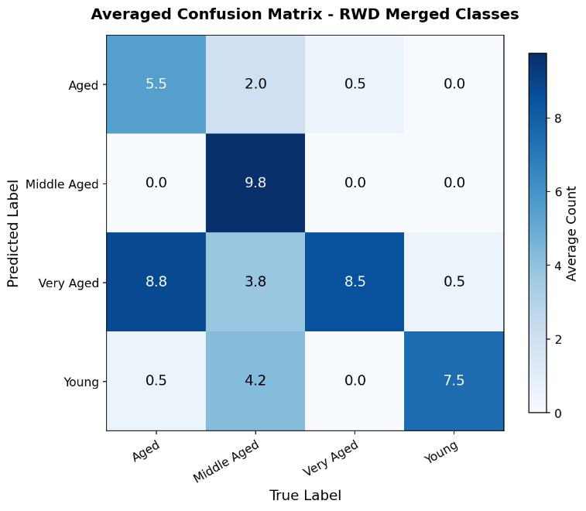
Figure 2. Confusion matrix averaged over the four cross-validation folds

Table 3. Averaged four-fold cross-validation performance metrics for Experiment 1
$${Recall}_{M}$$ | $${\text{Specificity}}_{M}$$ | $${\text{Precision}}_{M}$$ | $${\text{F-score}}_{M}$$ | ACC | ${\text{G-Mean}}_{M}$ | AUC
0.688 | 0.878 | 0.631 | 0.658 | 0.802 | 0.706 | 0.968

3.2. Experiment 2:
Compared to Experiment 1, performance metrics declined after excluding the Very Young and Young classes according to Table 4 and Figure 3. Specifically, the macro-averaged G-Mean decreased from 0.706 to 0.591, and the F-score declined from 0.658 to 0.540. This reduction in performance likely reflects the narrower age range and increased biological homogeneity among older, treatment-eligible animals, which reduces class separability and makes prediction more challenging.

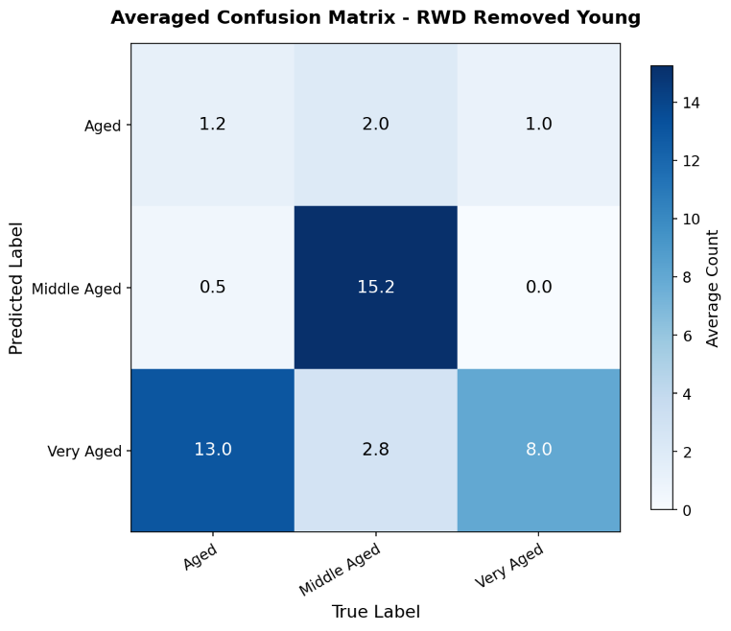
Figure 3. Confusion matrix averaged over the four cross-validation folds

Table 4. Averaged four-fold cross-validation for Experiment 2
$${Recall}_{M}$$ | $${\text{Specificity}}_{M}$$ | $${\text{Precision}}_{M}$$ | $${\text{F-score}}_{M}$$ | ACC | ${\text{G-Mean}}_{M}$ | AUC
0.577 | 0.807 | 0.514 | 0.540 | 0.706 | 0.591 | 0.902

The ROC curves are shown in Figure 3 demonstrate that the BWMD model maintains strong discriminative performance in both experiments. Although overall performance is higher in Experiment 1 (macro-averaged AUC = 0.9675), the model in both experiments remains highly effective in identifying the Middle-Aged class, which achieved the highest class-specific AUC values (0.9957 and 0.9611, respectively).

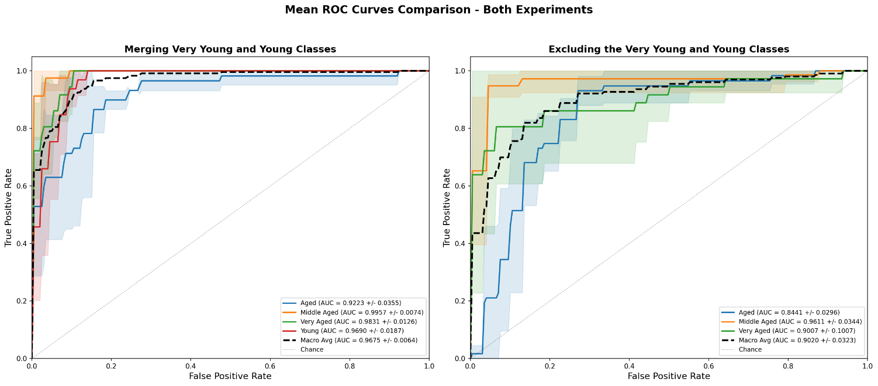
Figure 4. Mean ROC curves comparison for Experiment 1 (left) and Experiment 2 (right). ROC: Receiving operating curve; AUC: Area under the ROC curve; Macro Avg: Macro-averaged AUC

4. Discussion

By applying the BWMD framework to neurovascular aging, we were able to utitlize all 214 mouse records for analysis despite substantial missing data. The novelty of our work lies in three key contributions: first, we demonstrate that a BWMD model can be effectively used to predict vascular biological age, a metric that reflects functional organ decline beyond chronological age, using p16-3MR neurovascular data without requiring complete-case exclusion or imputation methods that often assume random missingness patterns. Second, we show that integrating neurovascular phenotypes with senescence-related cellular measures enables meaningful stratification of age-related BBB disruption across treatment conditions, including natural aging, genetic senescent cell clearance via GCV, and pharmacological senolysis via navitoclax. Third, we show that our BWMD framework offers a reliable approach for identifying vascular and senescence-related variables most strongly linked to BBB disruption, even in the presense of incomplete data.

Prior studies in cerebromicrovascular aging have used diverse high-dimensional variables from multiple biological modalities, such as transcriptomics and physiological phenotyping. For example, Csik et al. (2025) focused on physiological metrics, such as BBB permeability assessed via fluorescent dextran tracers, capillary density, and NVC responses, to explore the relationship between endothelial senescence and microvascular rarefaction. In contrats, Kiss et al. (2020) applied data science techniques to single-cell RNA sequencing (scRNA-seq) data to extract high-dimensional transcriptomic variables. Rather than relying on single markers, they created composite “Senescence Enrichment Scores” based on core senescence genes (e.g., Cdkn2a, Trp53), effector genes, and SASP factors to distinguish rare senescent endothelial cells from noise. Ahire et al. (2023) focused on structural and barrier integrity, using variables such as vessel skeleton density to quantify microvascular rarefaction and multi-size fluorescent tracers (3kDa–500kDa) to map permeability, alongside spatial transcriptomics. Other studies (Tarantini et al., 2021; Yabluchanskiy et al., 2020) focused on functional metrics, including changes in cerebral blood flow and cognitive error rates from RAWM assays. Yabluchanskiy et al. (2020) further extended their approach by integrating lipidomic markers, including vasodilators such as epoxyeicosatrienoic acids and oxidative stress markers.

However, these studies often faced susbtantial missing data, particularly in multimodal preclinical studies where large portions of data from specific biological measures are absent. For example, in our dataset, key measures such as BBB permeability were available for approximately 73.8–83.6% of animals. In contrast, other modalities had considerably lower coverage: NVC data were available for only 24.3% of animals, microvascular morphometric measures (e.g., vascular length density and vascular density) for 27.1%, and flow cytometry–derived senescent cell counts were complete in only 22.4% of records. Missingness was especially substantial in specific groups; NVC data were absent in 93.1% of Middle-Aged mice, and flow cytometry measurements were missing for 100% of animals in the Navitoclax treatment group. This pattern of “block-wise” missingness, where entire sets of variables are systematically absent, is different from the random missingness more commonly observed in clinical datasets. Such structured missing data patterns pose challenges for conventional imputation methods , which typically assume randomness and may introduce bias in this setting. The BWMD framework addresse this limitation by preserving all 214 samples for anlaysis while enabling accurate prediction of vascular biological age.

Our findings from Experiment 1 provide the first evidence that the BWMD framework can be effectively applied to predict vascular biological age. By merging the Very Young and Young cohorts to address class imbalance and utilizing SMOTE oversampling, the model achieved an average accuracy of 80.2% (average G-Mean: 70.6%) across the full cohort of 214 subjects, nearly nine times larger than the 24 subjects available under complete-case analysis. The aggregated confusion matrix demonstrates strong predictive performance for the consolidated “Young” class (4–14 months), with 7.5 of 8 (averaged across all folds) subjects correctly classified. This high accuracy is attributable to the experimental design, as this cohort consisted exclusively of untreated controls, presenting a healthy neurovascular phenotype characterized by intact BBB integrity. The model successfully distinguished this baseline state from senescent-associated profiles. A critical aspect of the analysis involves the Middle-Aged group (15–17 months), which represents the biological inflection point for the endothelial senescence onset (Csik et al., 2025). While 9.8 middle-aged subjects (averaged across all folds) were correctly identified, the model showed bidirectional misclassification: 4.2 were predicted as Young, 3.8 as Very Aged and 2 as Aged. Analysis of the treatment distribution within this age group indicates that this divergences align with therapeutic response.

As observed in Figure 1, the Middle-Aged group included a balanced distribution of untreated controls and animals receiving senolytic interventions (GCV and ABT-263). Subjects misclassified as Young likely represent treatment-responsive animals in which senolytic therapy restored microvascular integrity, particularly by reducing BBB leakage, shifting their biological signature toward a healthier baseline phenotype. In contrast, subjects predicted as Very Aged likely related to the untreated or non-responsive animals exhibiting accelerated vascular decline and more severe senescence-associated dysfunction. This interpretation is further supported by the Very Aged group (21–32 months), which contained the highest portion of untreated animals and demonstrated a strong association between the Very Aged label and severe functional impairment (Figure 1).

Experiment 2 builds upon the findings of Experiment 1 to distinguish vascular biological age specifically within the biological inflection point of endothelial senescence, focusing on subjects aged 15 months and older. The exclusion of Very Young and Young control groups reduced the dataset to 180 mice samples and exposed the algorithm to non-random missingness patterns, where specific functional blocks were systematically missing depending on age or treatment category. For instance, the Middle-Aged group (15–17 months) retained high availability of BBB permeability data using 40 kDa tracers (missing in only 3.4% of cases), but lacked NVC data in 93.1% of cases. The absence of NVC measurements, critical for assessing dynamic blood flow regulation, required the model to characterize this group primarily through structural barrier integrity markers. In contrast, the Very Aged group (21–32 months) had high availability of LTP data (present in 90.6% of cases) but lacked BBB permeability data in 37.5% of cases, effectively shifting the phenotypic definition toward synaptic functional measures. In addition, the Navitoclax (ABT-263) senolytic treatment group completely lacked EC-FC data (100% missing). Because, EC-FC measures the direct burden of senescent cells, its absence prevents the explicit quantification of senolytic clearance. Despite the dataset lacked these key variable blocks across different groups, the model achieved an average accuracy of 70.6%, a macro-specificity of 80.7%, and an average G-Mean of 59.1%. The results demonstrates that the block-wise algorithm successfully extracted latent biological signals from the fragmented data, inferring the therapeutic efficacy of Navitoclax through downstream functional surrogates, such as BBB integrity, even in the absence of direct senescent cell measurements.

The second contribution of this study demonstrates that integrating neurovascular phenotypes with senescence-related cellular measures enables meaningful stratification of age-related BBB disruption. Our findings support this by showing that functional vascular metrics can serve as reilable proxy for cellular senescence burden when direct counts are unavailable. In the Navitoclax (ABT-263) cohort, the EC-FC data were completely absent (100% missing). Despite the inability to directly quantify p16^{Ink4a}-positive endothelial cells in this group, the model accurately predicted a lower vascular biological age relative to the chronological age. This classification was driven by preserved neurovascular phenotypes, particularly maintained BBB integrity against 40 kDa dextran and sustained vascular density, rather than explicit senescence counts. These results indicate that the block-wise framework correctly learned the inverse relationship between senescence clearance and microvascular dysfunction from the Ganciclovir and No-Treatment groups. Consequently, it was able to infer the reduced senescence load in ABT-263 mice solely from their improved physiological biomarlers. This integrative capacity addresses a limitation observed in prior domain-specific studies. For instance, Kiss et al. (2020) utilized single-cell RNA sequencing to construct senescence enrichment scores but did not incorporate functional BBB leakage assays, limiting the ability to directly link transcriptomic states to organ-level barrier failure. Similarly, Tarantini et al. (2021) and Ahire et al. (2023) provided detailed characterization of NVC responses and vessel skeleton density, respectively, yet often lacked the simultaneous, animal-matched cellular senescence measurements necessary to map the cellular-to-functional trajectory. By fusing these fragmented modalities within an analytical framework, our study confirms that neurovascular phenotypes provide a reliable information of the underlying senescence state, allowing for the assessment of therapeutic efficacy even in the presence of severe, structured missingness.

To identify which vascular and senescence-associated variables most strongly track BBB disruption, we utilized Spearman rank correlation ($\left|ρ\right|)$ to quantify the predictive strength of each modality against the vascular biological age label across both experiments. Our findings indicate that the EC-FC variable was consistently the strongest biological predictor in both configurations, with correlation coefficients of $\left|ρ\right| =$0.88 in Experiment 1 and $\left|ρ\right| =$0.82 in Experiment 2. LTP and NVC also demonstrated strong associations, with correlations ranging from $\left|ρ\right| =$ 0.60–0.70 and $\left|ρ\right| =$0.58–0.68 respectively. Notably, these high-signal variables were characterized by substantial sparsity, exhibiting approximately 56%–81% missingness across the dataset.

We also observed that cognitive performance metrics including RAWM total errors demonstrated moderate predictive power with correlations between 0.53 and 0.58, outperforming several structural vascular measures. In contrast, BBB permeability assessed via 40 kDa dextran showed the weakest predictive correlation with vascular biological age ($\left|ρ\right| ≈$0.20–0.23), despite having the lowest missingness rate of 15%–16%. This discrepancy demonstrates that standard listwise deletion would discard the most informative biological signals from EC-FC and NVC in favor of less discriminative tracer data. The block-wise framework overcomes this limitation by preserving and high-informational sparse physiological signals to accurately map the vascular aging trajectory.

While our framework effectively addresses block-wise missingness, the study has several limitations that suggest areas for future research. First, although the sample size of 214 subjects is considerable for a preclinical longitudinal study, it remains relatively modest for high-dimensional machine learning. Increasing the cohort size would likely improve the robustness of the predictive performance, particularly given the high degree of sparsity (missingness >75%) in the most informative variable blocks. Second, the BWMD algorithm maps test instances to appropriate predictors based on the distinct missingness profiles established during training. But if a test instance hows missingness profiles that was never observed in the training set, a scenario more likely in very small multi-omics datasets, the model cannot compute the probabilities and , cannot produce a prediction. Third, the current BWMD algorithm is formulated as a multi-class logistic regression model (see Appendix). Although effective for this classification task, its linear structure may not fully capture complex, non-linear interactions among heterogeneous data sources. Future work could extend this framework to non-linear models, such as block-wise adaptations of deep neural networks or gradient boosting methods (e.g., XGBoost), to better model the complex relations between transcriptomic, physiological, and morphological variables. Third, while we applied SMOTE to mitigate class imbalance, future work could exploit cost-sensitive learning, assigning higher penalties to misclassifications of minority classes to improve sensitivity without generating synthetic data points. Finally, although the present study integrates 23 functional and cellular variables, the proposed algorithm is designed to handle high-dimensional multi-omics data. Future investigations should incorporate additional modalities, such as single-cell transcriptomics or proteomics, to fully leverage the block-wise framework in characterizing the multifactorial landscape of neurovascular aging.

Despite these limitations, the results presented in this study demonstrate that the BWMD framework provides a robust and practical approach for predicting vascular biological age under conditions of severe, structured missingness. The model retained all 214 mouse records for analysis, achieving an average accuracy of 80.2% in Experiment 1 and 70.6% in Experiment 2, while successfully leveraging high-informational but sparsely observed variables such as endothelial cell senescence counts (|ρ| = 0.88) and neurovascular coupling responses (|ρ| = 0.68). The framework inferred the therapeutic effects of senolytic interventions even when direct cellular measures were systematically absent, confirming its capacity to extract latent biological signals from fragmented multi-modal data. These findings establish a foundation for applying block-wise missing data methods to broader preclinical and translational studies of cerebrovascular aging.

References
Ahire, C., Nyul-Toth, A., DelFavero, J., Gulej, R., Faakye, J. A., Tarantini, S., Kiss, T., Kuan-Celarier, A., Balasubramanian, P., Ungvari, A., & others. (2023). Accelerated cerebromicrovascular senescence contributes to cognitive decline in a mouse model of paclitaxel (Taxol)-induced chemobrain. Aging Cell, 22(7), e13832.
Baena-Miret, S., Reverter, F., Sánchez, A., & Vegas, E. (2025). A Two-Step Algorithm for Handling Block-Wise Missing Data in Multi-Omics. Applied Sciences, 15(7), 3650.
Baena-Miret, S., Reverter, F., & Vegas, E. (2024). A framework for block-wise missing data in multi-omics. Plos One, 19(7), e0307482.
Baker, D. J., Childs, B. G., Durik, M., Wijers, M. E., Sieben, C. J., Zhong, J., A. Saltness, R., Jeganathan, K. B., Verzosa, G. C., Pezeshki, A., & others. (2016). Naturally occurring p16Ink4a-positive cells shorten healthy lifespan. Nature, 530(7589), 184–189.
Baker, D. J., Petersen, R. C., & others. (2018). Cellular senescence in brain aging and neurodegenerative diseases: evidence and perspectives. The Journal of Clinical Investigation, 128(4), 1208–1216.
Baker, D. J., Wijshake, T., Tchkonia, T., LeBrasseur, N. K., Childs, B. G., Van De Sluis, B., Kirkland, J. L., & Van Deursen, J. M. (2011). Clearance of p16Ink4a-positive senescent cells delays ageing-associated disorders. Nature, 479(7372), 232–236.
Borchert, R. J., Azevedo, T., Badhwar, A., Bernal, J., Betts, M., Bruffaerts, R., Burkhart, M. C., Dewachter, I., Gellersen, H. M., Low, A., & others. (2023). Artificial intelligence for diagnostic and prognostic neuroimaging in dementia: A systematic review. Alzheimer’s & Dementia, 19(12), 5885–5904.
Brainin, M., Feigin, V. L., Norrving, B., Martins, S. C. O., Hankey, G. J., & Hachinski, V. (2020). Global prevention of stroke and dementia: the WSO Declaration. The Lancet Neurology, 19(6), 487–488.
Cai, Y., Mok, V. C. T., & Markus, H. S. (2026). Vascular dementia: World Stroke Organization fact sheet 2026. International Journal of Stroke, 17474930251404244.
Chang, J., Wang, Y., Shao, L., Laberge, R.-M., Demaria, M., Campisi, J., Janakiraman, K., Sharpless, N. E., Ding, S., Feng, W., & others. (2016). Clearance of senescent cells by ABT263 rejuvenates aged hematopoietic stem cells in mice. Nature Medicine, 22(1), 78–83.
Csik, B., Nyúl-Tóth, Á., Gulej, R., Patai, R., Kiss, T., Delfavero, J., Nagaraja, R. Y., Balasubramanian, P., Shanmugarama, S., Ungvari, A., & others. (2025). Senescent Endothelial Cells in Cerebral Microcirculation Are Key Drivers of Age-Related Blood–Brain Barrier Disruption, Microvascular Rarefaction, and Neurovascular Coupling Impairment in Mice. Aging Cell, e70048.
Cumplido-Mayoral, I., Garc\’\ia-Prat, M., Operto, G., Falcon, C., Shekari, M., Cacciaglia, R., Milà-Alomà, M., Lorenzini, L., Ingala, S., Wink, A. M., & others. (2023). Biological brain age prediction using machine learning on structural neuroimaging data: Multi-cohort validation against biomarkers of Alzheimer’s disease and neurodegeneration stratified by sex. Elife, 12, e81067.
Demaria, M., Ohtani, N., Youssef, S. A., Rodier, F., Toussaint, W., Mitchell, J. R., Laberge, R.-M., Vijg, J., Van Steeg, H., Dollé, M. E. T., & others. (2014). An essential role for senescent cells in optimal wound healing through secretion of PDGF-AA. Developmental Cell, 31(6), 722–733.
Faakye, J., Nyúl-Tóth, Á., Muranyi, M., Gulej, R., Csik, B., Shanmugarama, S., Tarantini, S., Negri, S., Prodan, C., Mukli, P., & others. (2024). Preventing spontaneous cerebral microhemorrhages in aging mice: a novel approach targeting cellular senescence with ABT263/navitoclax. Geroscience, 46(1), 21–37.
Farr, J. N., Xu, M., Weivoda, M. M., Monroe, D. G., Fraser, D. G., Onken, J. L., Negley, B. A., Sfeir, J. G., Ogrodnik, M. B., Hachfeld, C. M., & others. (2017). Targeting cellular senescence prevents age-related bone loss in mice. Nature Medicine, 23(9), 1072–1079.
Fernández-Pérez, I., Jiménez-Balado, J., Lazcano, U., Giralt-Steinhauer, E., Rey Álvarez, L., Cuadrado-Godia, E., Rodr\’\iguez-Campello, A., Macias-Gómez, A., Suárez-Pérez, A., Revert-Barberá, A., & others. (2023). Machine learning approximations to predict epigenetic age acceleration in stroke patients. International Journal of Molecular Sciences, 24(3), 2759.
Grandini, M., Bagli, E., & Visani, G. (2020). Metrics for multi-class classification: an overview. ArXiv Preprint ArXiv:2008.05756.
Hand, D. J., & Till, R. J. (2001). A simple generalisation of the area under the ROC curve for multiple class classification problems. Machine Learning, 45(2), 171–186.
Kim, H.-N., Chang, J., Iyer, S., Han, L., Campisi, J., Manolagas, S. C., Zhou, D., & Almeida, M. (2019). Elimination of senescent osteoclast progenitors has no effect on the age-associated loss of bone mass in mice. Aging Cell, 18(3), e12923.
Kiss, T., Nyúl-Tóth, Á., Balasubramanian, P., Tarantini, S., Ahire, C., DelFavero, J., Yabluchanskiy, A., Csipo, T., Farkas, E., Wiley, G., & others. (2020). Single-cell RNA sequencing identifies senescent cerebromicrovascular endothelial cells in the aged mouse brain. Geroscience, 42(2), 429–444.
Li, Y., Jin, J., Ma, J., Zhu, F., Jin, B., Liang, J., & Chen, C. L. P. (2023). Imbalanced least squares regression with adaptive weight learning. Information Sciences, 648, 119541.
Linh, T. T. D., Hsieh, Y.-C., Huang, L.-K., & Hu, C.-J. (2022). Clinical trials of new drugs for vascular cognitive impairment and vascular dementia. International Journal of Molecular Sciences, 23(19), 11067.
Onyango, I. G., Jauregui, G. V, Čarná, M., Bennett Jr, J. P., & Stokin, G. B. (2021). Neuroinflammation in Alzheimer’s disease. Biomedicines, 9(5), 524.
Rashid, I., Kalandria, A., Kaur, N., Sharma, A., Qadir, S., Singh, R., & Ifaq, Q. (2024). Role of Cellular Senescence in Neurodegeneration: Mechanisms and Therapeutic Implications. Journal of Pharma Insights and Research, 2(2), 215–225.
Robbins, P. D., Jurk, D., Khosla, S., Kirkland, J. L., LeBrasseur, N. K., Miller, J. D., Passos, J. F., Pignolo, R. J., Tchkonia, T., & Niedernhofer, L. J. (2021). Senolytic drugs: reducing senescent cell viability to extend health span. Annual Review of Pharmacology and Toxicology, 61(1), 779–803.
Roos, C. M., Zhang, B., Palmer, A. K., Ogrodnik, M. B., Pirtskhalava, T., Thalji, N. M., Hagler, M., Jurk, D., Smith, L. A., Casaclang-Verzosa, G., & others. (2016). Chronic senolytic treatment alleviates established vasomotor dysfunction in aged or atherosclerotic mice. Aging Cell, 15(5), 973–977.
Sokolova, M., & Lapalme, G. (2009). A systematic analysis of performance measures for classification tasks. Information Processing & Management, 45(4), 427–437.
Sweeney, M. D., Kisler, K., Montagne, A., Toga, A. W., & Zlokovic, B. V. (2018). The role of brain vasculature in neurodegenerative disorders. Nature Neuroscience, 21(10), 1318–1331.
Sweeney, M. D., Sagare, A. P., & Zlokovic, B. V. (2018). Blood–brain barrier breakdown in Alzheimer disease and other neurodegenerative disorders. Nature Reviews Neurology, 14(3), 133–150.
T O’Brien, J., Erkinjuntti, T., Reisberg, B., Roman, G., Sawada, T., Pantoni, L., Bowler, J. V, Ballard, C., DeCarli, C., Gorelick, P. B., & others. (2003). Vascular cognitive impairment. The Lancet Neurology, 2(2), 89–98.
Tarantini, S., Balasubramanian, P., Delfavero, J., Csipo, T., Yabluchanskiy, A., Kiss, T., Nyul-Toth, A., Mukli, P., Toth, P., Ahire, C., & others. (2021). Treatment with the BCL-2/BCL-xL inhibitor senolytic drug ABT263/Navitoclax improves functional hyperemia in aged mice. Geroscience, 43(5), 2427–2440.
Toth, P., Tarantini, S., Csiszar, A., & Ungvari, Z. (2017). Functional vascular contributions to cognitive impairment and dementia: mechanisms and consequences of cerebral autoregulatory dysfunction, endothelial impairment, and neurovascular uncoupling in aging. American Journal of Physiology-Heart and Circulatory Physiology, 312(1), H1–H20.
Ungvari, A., Nyúl-Tóth, Á., Patai, R., Csik, B., Gulej, R., Nagy, D., Shanmugarama, S., Benyó, Z., Kiss, T., Ungvari, Z., & others. (2025). Cerebromicrovascular senescence in vascular cognitive impairment: does accelerated microvascular aging accompany atherosclerosis? GeroScience, 1–14.
Ungvari, Z., Podlutsky, A., Sosnowska, D., Tucsek, Z., Toth, P., Deak, F., Gautam, T., Csiszar, A., & Sonntag, W. E. (2013). Ionizing radiation promotes the acquisition of a senescence-associated secretory phenotype and impairs angiogenic capacity in cerebromicrovascular endothelial cells: role of increased DNA damage and decreased DNA repair capacity in microvascular radiosensitivity. Journals of Gerontology Series A: Biomedical Sciences and Medical Sciences, 68(12), 1443–1457.
van Dinther, M., Voorter, P. H. M., Jansen, J. F. A., Jones, E. A. V, van Oostenbrugge, R. J., Staals, J., & Backes, W. H. (2022). Assessment of microvascular rarefaction in human brain disorders using physiological magnetic resonance imaging. Journal of Cerebral Blood Flow & Metabolism, 42(5), 718–737.
Van Skike, C. E., & Galvan, V. (2020). Cerebrovascular dysfunction links aging to neurological disease. Aging (Albany NY), 12(14), 13847.
Wu, Q., Zhang, J., Lei, P., Zhang, Z., Zhu, X., & Huang, C. (2025). An evidence-based analysis of machine learning prediction models for cognitive impairment in cerebral small vessel disease. Neuroscience, 586, 100–109.
Yabluchanskiy, A., Tarantini, S., Balasubramanian, P., Kiss, T., Csipo, T., Fülöp, G. A., Lipecz, A., Ahire, C., DelFavero, J., Nyul-Toth, A., & others. (2020). Pharmacological or genetic depletion of senescent astrocytes prevents whole brain irradiation–induced impairment of neurovascular coupling responses protecting cognitive function in mice. Geroscience, 42(2), 409–428.
Zhu, T., Lin, Y., & Liu, Y. (2017). Synthetic minority oversampling technique for multiclass imbalance problems. Pattern Recognition, 72, 327–340.

Appendix

Performance Metrics
To evaluate the performance of the predictive model in this multi-class classification task, several metrics were employed, including macro recall, macro specificity, macro precision, macro F1-score, macro G-mean, average accuracy, and averaged AUC (Grandini et al., 2020). These metrics, along with their mathematical definitions, are described below. In multi-class classification settings, class imbalance can render accuracy an unreliable performance measure. To address this issue, we employ the macro-averaged F-score (F${-score}_{M}$), which is defined as the harmonic mean of macro-averaged precision (${Precision}_{M}$, also known as positive predictive value) and macro-averaged recall (${Recall}_{M}$, also known as sensitivity). Macro-averaging assigns equal weight to each class, in contrast to micro-averaging, which is dominated by majority classes (Grandini et al., 2020; Sokolova & Lapalme, 2009). All metrics are computed using equations derived from the multi-class confusion matrix. Assume $K$is the number of classes, $TP_{k}$is the number of true positives for class $k$, $FN_{k}$is the number of false negatives for class $k$, $TN_{k}$is the number of true negatives for class $k,$and $FP_{k}$is the number of false positives for class $k$.
$${Recall}_{M}=\frac{1}{K}\sum_{k=1}^{K}{\frac{TP_{k}}{TP_{k}+FN_{k}}}$$
$${\text{Specificity}}_{M} =\frac{1}{K}\sum_{k=1}^{K}{\frac{TN_{k}}{TN_{k}+FP_{k}}}$$
$${\text{Precision}}_{M} =\frac{1}{K}\sum_{k=1}^{K}{\frac{TP_{k}}{TP_{k}+FP_{k}}}$$
$${\text{F-score}}_{M}=\frac{2. Precision_{M}⋅Recall_{M}}{Precision_{M}+Recall_{M}}$$
$$\text{Average Accuracy (ACC)}=\frac{1}{K}\sum_{k=1}^{K}{\frac{TP_{k}+TN_{k}}{TP_{k}+FN_{k}+FP_{k}+TN_{k}}}$$
Macro-averaged G-Mean is the average G-Mean across all classes (where G-Mean is the geometric mean of recall and specificity). It is defined as (Li et al., 2023):
$${\text{G-Mean}}_{M} =\frac{1}{K}\sum_{k=1}^{K}{\sqrt{\frac{TP_{k}}{TP_{k}+FN_{k}}⋅\frac{TN_{k}}{TN_{k}+FP_{k}}}}$$
Area Under the Curve (AUC) measures the probability that a randomly chosen positive instance is ranked higher than a randomly chosen negative instance. An AUC of 1.0 represents perfect classification, while 0.5 represents random classification. For multiclass problems, Hand & Till (2001) extended AUC by averaging pairwise comparisons across all class pairs, defined as:
$$AUC=\frac{2}{K(K-1)}\sum_{i<j}{\overset{^}{A}}(i,j)$$
where Â(i,j) is the average of the pairwise AUC values between classes i and j, which is computed as:
$$\hat{A}(i,j)=\frac{\hat{A}(i∣j)+\hat{A}(j∣i)}{2}$$

Â(i|j) is the probability that a randomly drawn member of class j will have a lower estimated probability of belonging to class i than a randomly drawn member of class i.

Mathematical Formulation of Block-Wise Missing Data (BWMD) Model
Let the data be denoted by $X∈R^{n×p}$ where $n$ represents the number of samples and $p$ represents the number of variables (or variables). The response variable $y∈\{1, 2,…,K\}$represents the class labels for each sample, where $K$is the number of classes. Consider a dataset consists of multiple blocks, where each block is treated as a distinct data source, with each represented by its own matrix. For each source $j∈\{1,…,S\}$, where $S$ denotes the number of data sources, the data matrix $X^{\left(j\right)}$captures the variables associated with the $j$-th source. Additionally, for each source $j$, we define a coefficient matrix $β^{\left(j\right)}=[β_{1}^{\left(j\right)},…,β_{K}^{\left(j\right)}]$, where each $β_{k}^{\left(j\right)}$is a column vector corresponding to class $k=1, 2, …, K$. The classification model is defined as:
$$\hat{y}=\sum_{j=1}^{S}{α_{j}}X^{\left(j\right)}β^{\left(j\right)}+ε$$
where $ε$is the noise term, and the weight $α_{j}$ is introduced to adjust the influence of each source within the classification model, allowing us to analyze the contribution of different variables and data sources. A key aspect of the BWMD algorithm is its ability to partition the dataset into profiles based on the availability of data. Rather than discarding observations with missing values, the method groups samples with similar missingness patterns into distinct profiles, which are represented by a binary indicator matrix. Let $pf$denote the set of all profiles, and $∣pf∣$represent the total number of profiles. For a given profile $m∈pf$, let $n_{m}$ denote the number of samples belonging to profile $m$, $X_{m}^{\left(j\right)}$represent the $n_{m}×p_{j}$data submatrix for source $j$, and $y_{m}$denote the $n_{m}$-dimensional response vector. This framework preserves informative information by allowing the model to perform variable-level analysis without the need to impute missing values. The optimization process is performed in two stages. In the first stage, we optimize the classification coefficients $β^{\left(j\right)}$for each source, while in the second stage, we optimize the source weights $α_{m,j}$, which represents the weight assigned to source $j$within profile $m$. For multi-class classification, we employ the log soft-max loss function, defined as:
$$l_{k}(\hat{y},y)=χ_{\left\{y = k\right\}}log⁡\left(\frac{e^{{\hat{y}}_{k}}}{\sum_{k^{'}=1}^{K}{e^{{\hat{y}}_{k^{'}}}}}\right),k=1,…,K,\hat{y}=({\hat{y}}_{1},…,{\hat{y}}_{K})∈R^{K}$$
where $\hat{y}$ is the vector of predicted scores for each class, $y$ is the true class label, and $χ_{\left\{y = k\right\}}$is the indicator function that returns 1 if $y=k,$and 0 otherwise. The goal is to minimize the average loss function across all profiles (Baena-Miret et al., 2025):

$$\min_{α,β}{-}\frac{1}{\left|pf\right|}\sum_{m∈pf}{\frac{1}{n_{m}}}\sum_{l=1}^{n_{m}}{\sum_{k=1}^{K}{χ_{\{{\left(y_{m}\right)}_{l}=k\}}}\log\left(\frac{\exp\left(\sum_{j=1}^{S}{α_{m,j}{\left(X_{m}^{\left(j\right)}\right)}_{l}β_{k}^{\left(j\right)}}\right)}{\sum_{k^{'}=1}^{K}{\exp\left(\sum_{j=1}^{S}{α_{m,j}{\left(X_{m}^{\left(j\right)}\right)}_{l}β_{k^{'}}^{\left(j\right)}}\right)}}\right)}+λΩ\left(β\right)$$

where $\left(y_{m})_{l}\right.$denotes the class label for the $l$-th sample in profile $m$, ${(X}_{m}^{\left(j\right)})_{l }$represents the $l$-th row of the data matrix for source $j$ in profile $m$, $λ$ is the regularization parameter, and $Ω(β)$ is the regularization function that helps control the complexity of the model and prevent overfitting. To solve this optimization problem, we apply a two-step iterative algorithm (Baena-Miret et al., 2024, 2025) that alternates between optimizing $β$and $α$, iterating until the objective function converges.

